3 – Exercises

3-1 Fish factory
In this exercise, the workshop participants draw a flowchart either from data provided in the process description below or from data collected during a first company visit. It is not so easy to convert collected data into a flowchart, therefore the participants will need some training.
Task: Draw a flowchart for a fish processing company
for the raw material fish and for water.

Process description:
Fresh fish from a nearby lake is delivered by boats and unloaded. First the fish is washed, weighed and stored temporarily in tubs filled with ice.

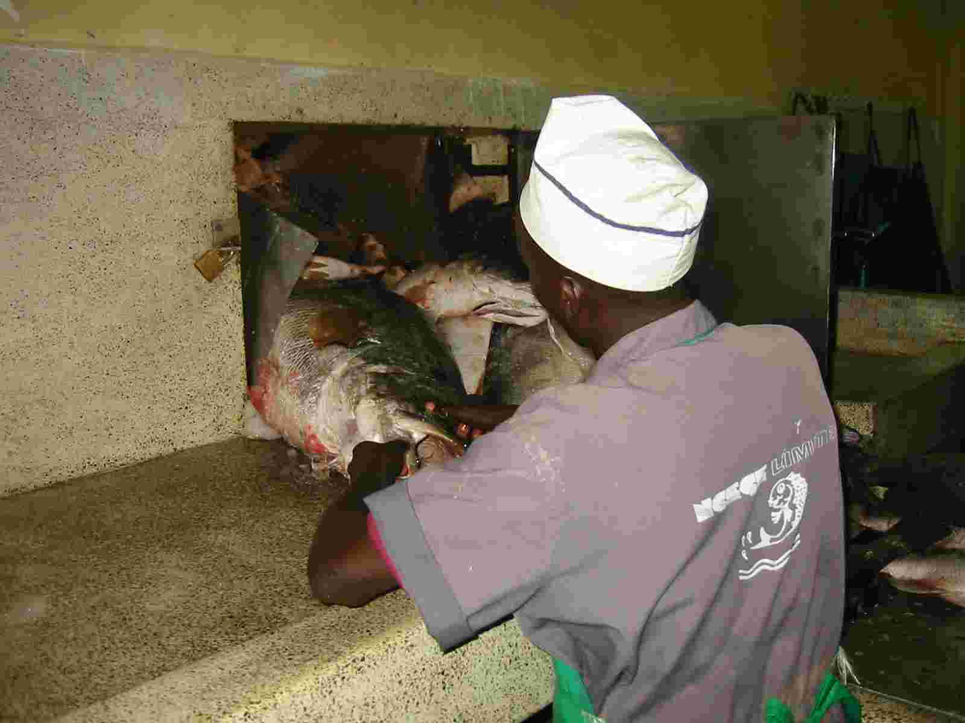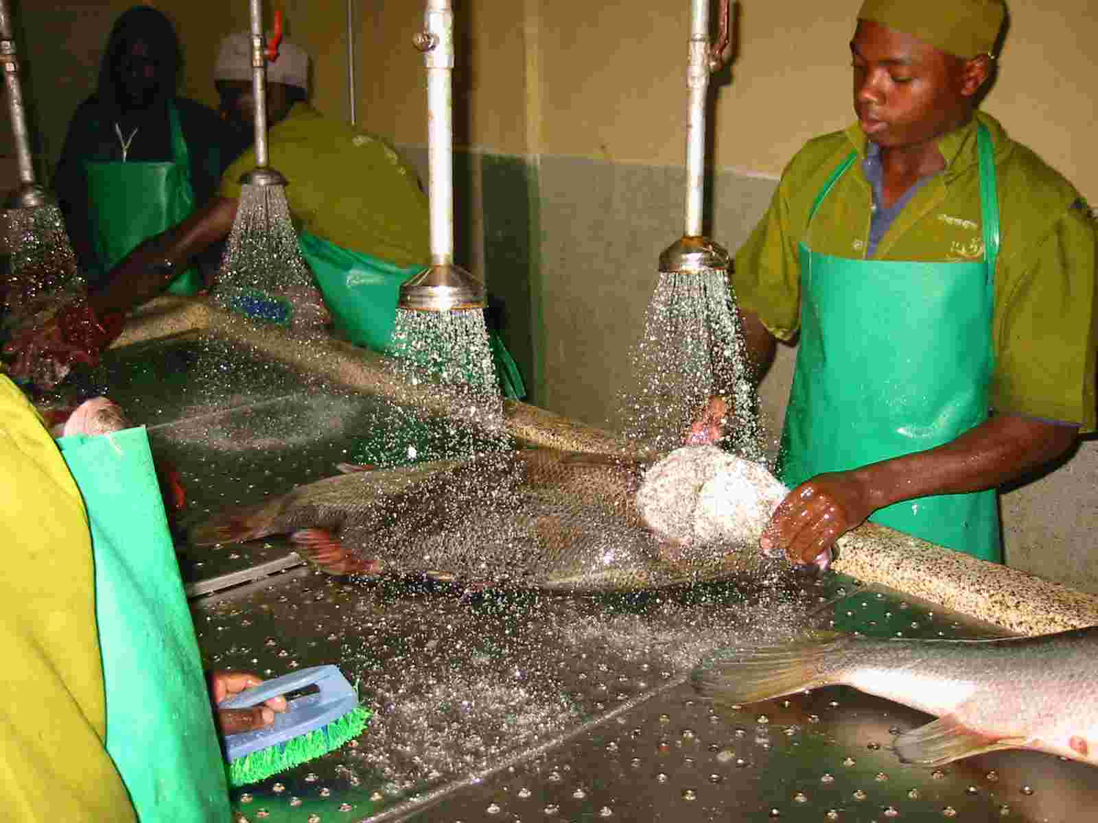
Figure 1: Unloading the fish Figure 2: Washing

Next, the fish is filleted, the skin is removed and the fillets are thoroughly cleaned. This cleaning process is called trimming. After yet another washing procedure, the product undergoes the final quality control. Then the fish is packed and stored in cooling rooms or deep frozen before it is finally shipped to the customers.
Fish waste (heads, fish bones, skin, quality reject, offal, etc.) from filleting, skinning and trimming is either given away to people from rural areas or processed into fish meal.
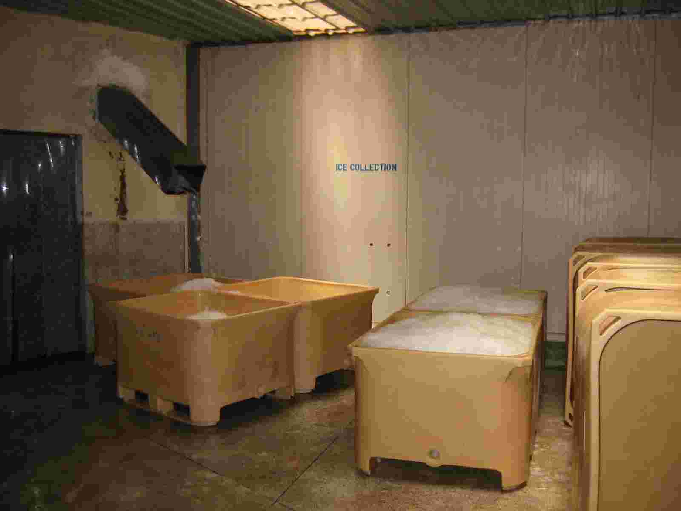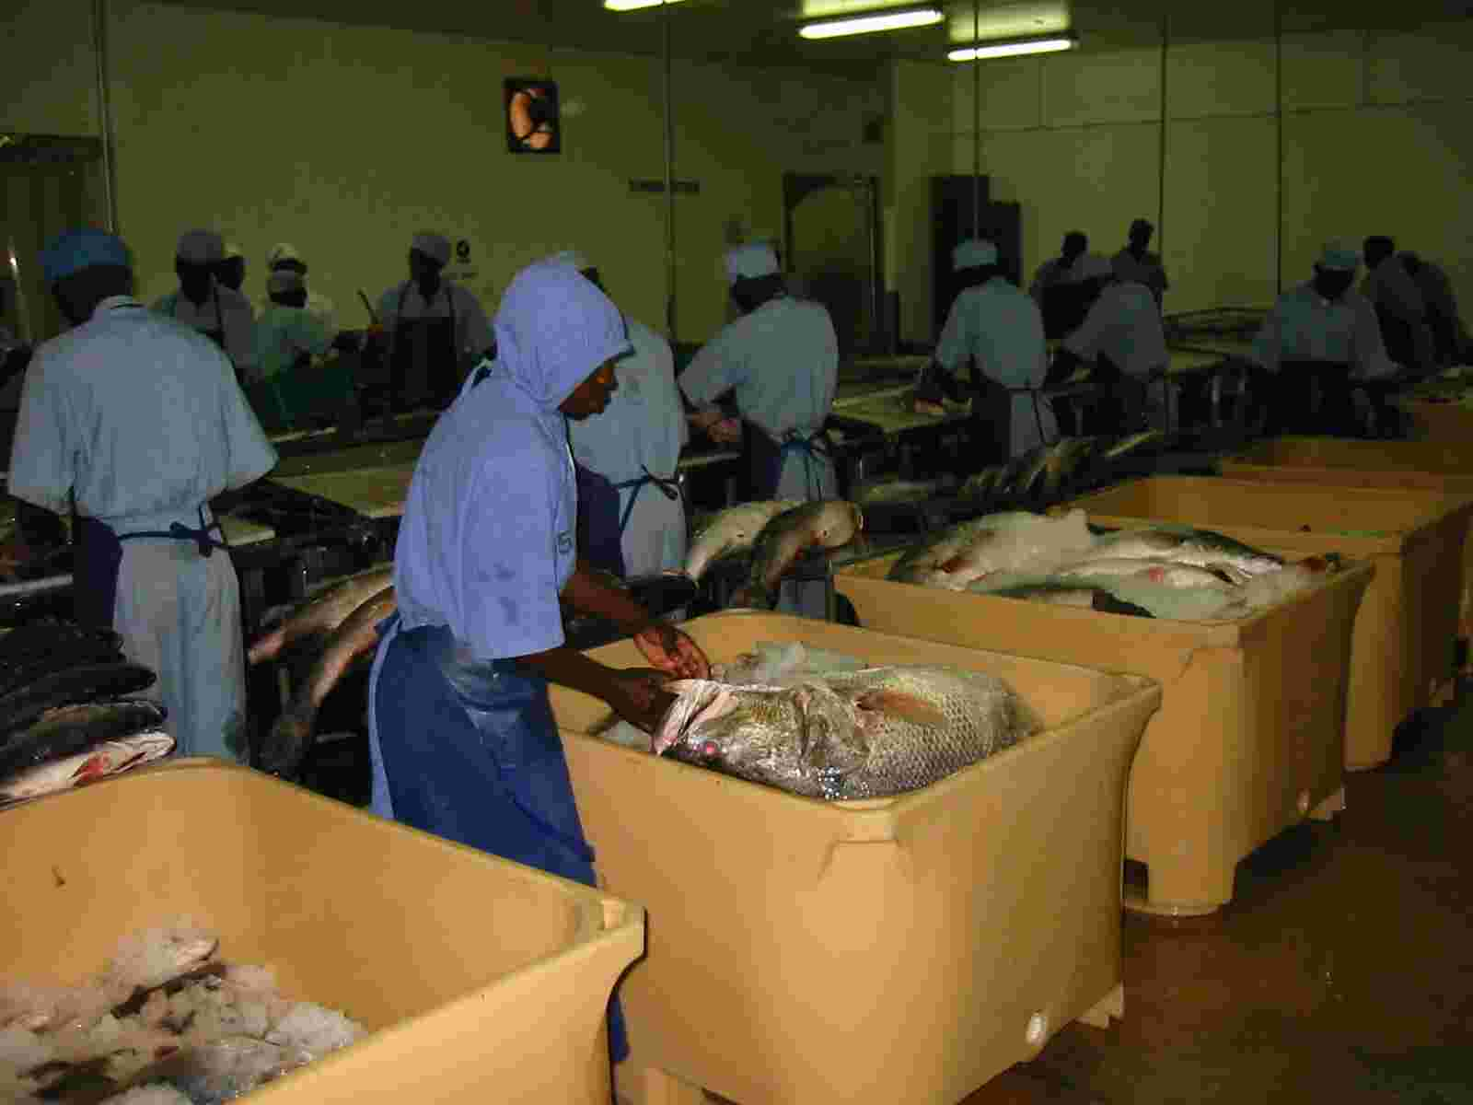
Figure 3: Tubs filled with ice Figure 4: Filleting the fish

The water used in the process is supplied by the public water utilities and cleaning one ton of fresh fish requires up to 11 m³ of water. Water is used permanently for the initial washing of the fish, in the filleting line, for skinning, trimming and final washing. In addition, the production line and all floors are cleaned with water and chemicals during production and after the end of work. The used tubs, fish trays and trucks are also washed with water. All effluent water is collected and treated in a small wastewater plant, where the BOD is lowered, and then discharged into a lake.
Large amounts of ice are produced daily to cool the fish in the tubs, especially during unloading, temporary storage and after skinning. The ice then remains in the empty tubs until they are washed by hand.
A central water-cooled chilling unit is used for cooling and freezing. The water is pumped to a cooling tower where it is cooled by evaporation and piped back to the condenser. Evaporation losses are automatically refilled. From time to time, the whole amount of water in the cooling cycle is drained.
Solution:
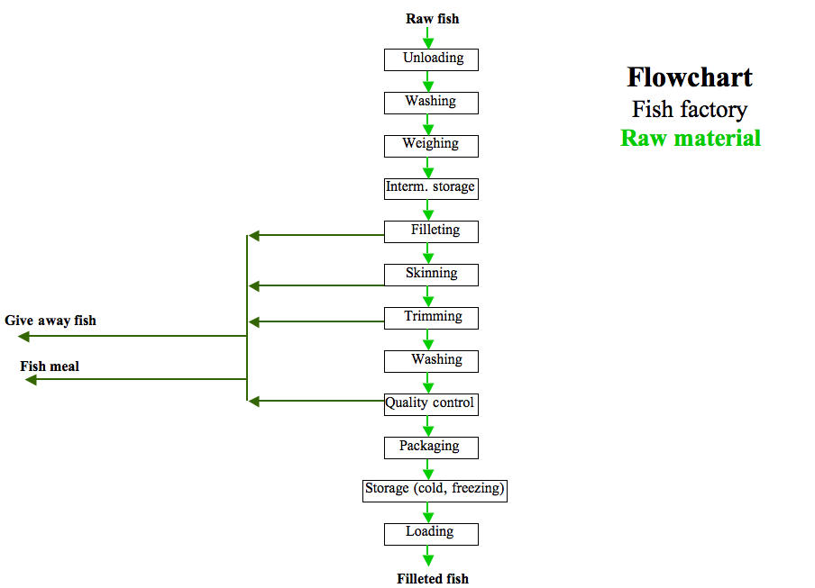
Figure 5: Flowchart raw material

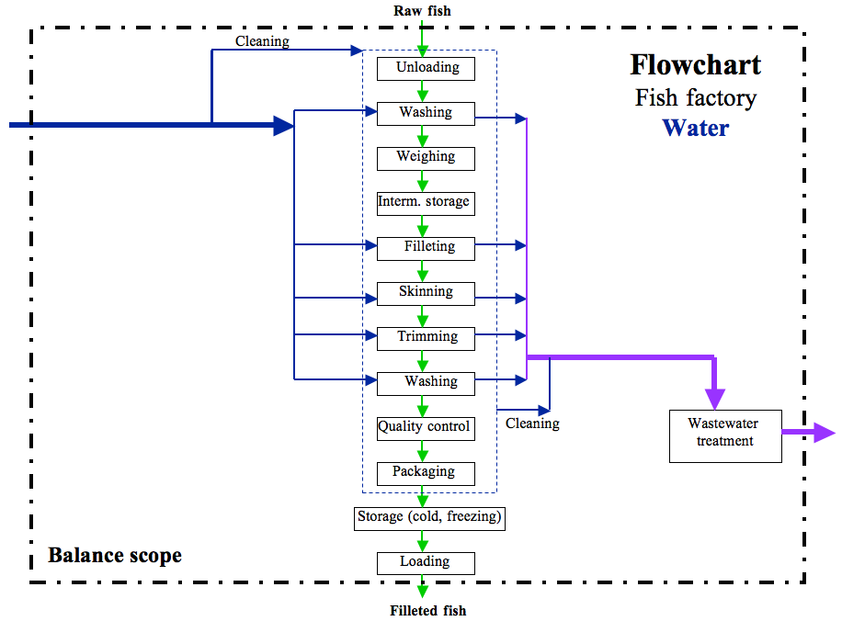
Figure 6: Flowchart water
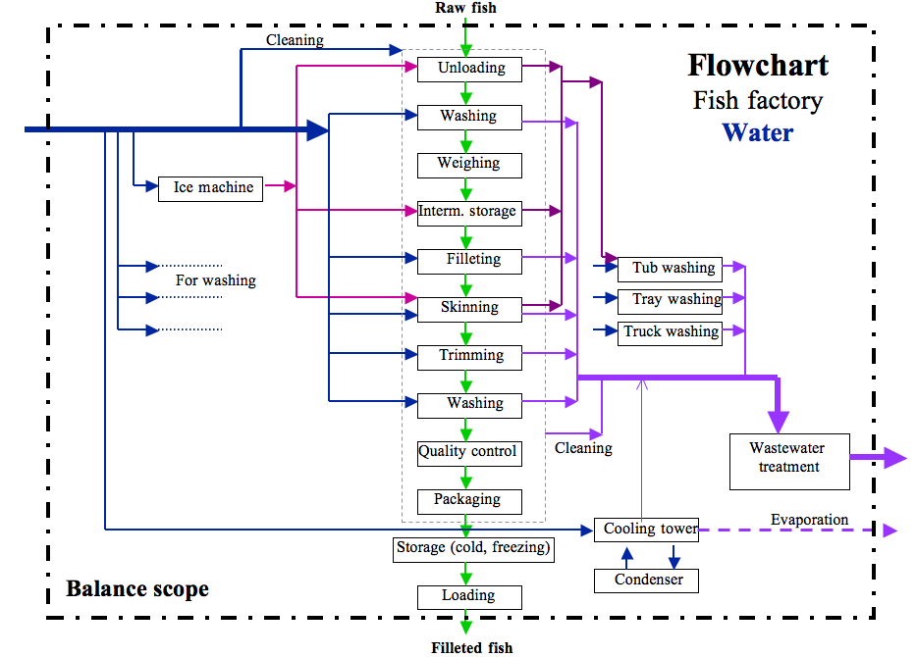
Figure 7: Flowchart water

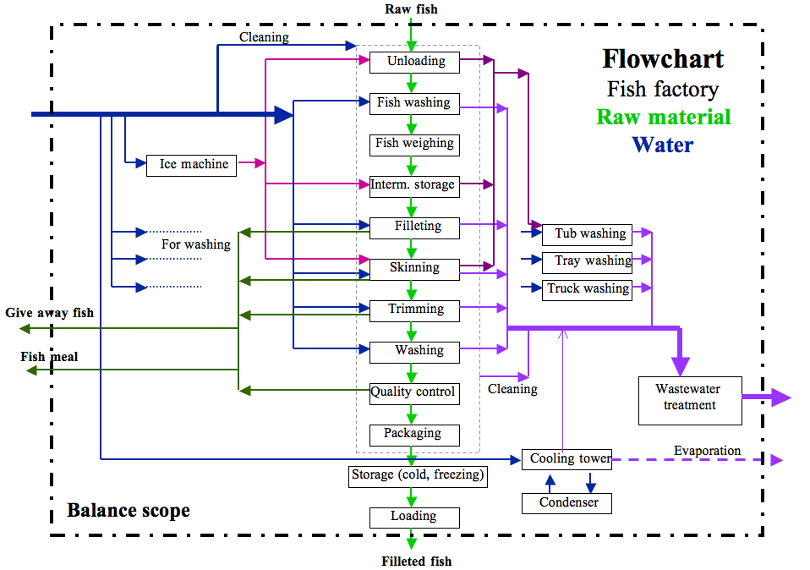
Figure 8: Flowchart raw material and water

3-2 Making coffee
This is an interactive exercise in which several groups of people (ideally groups of approximately four persons) have to analyse a concrete yet simple process.
Time: 10 minutes for the explanation, 40 to 60 minutes for group work, 15 to 30 minutes for the presentation and evaluation.
Prepare the equipment beforehand and explain the objectives of the exercise. The exercise can also be carried out without any equipment by simply calculating on the basis of existing data – see making coffee B.

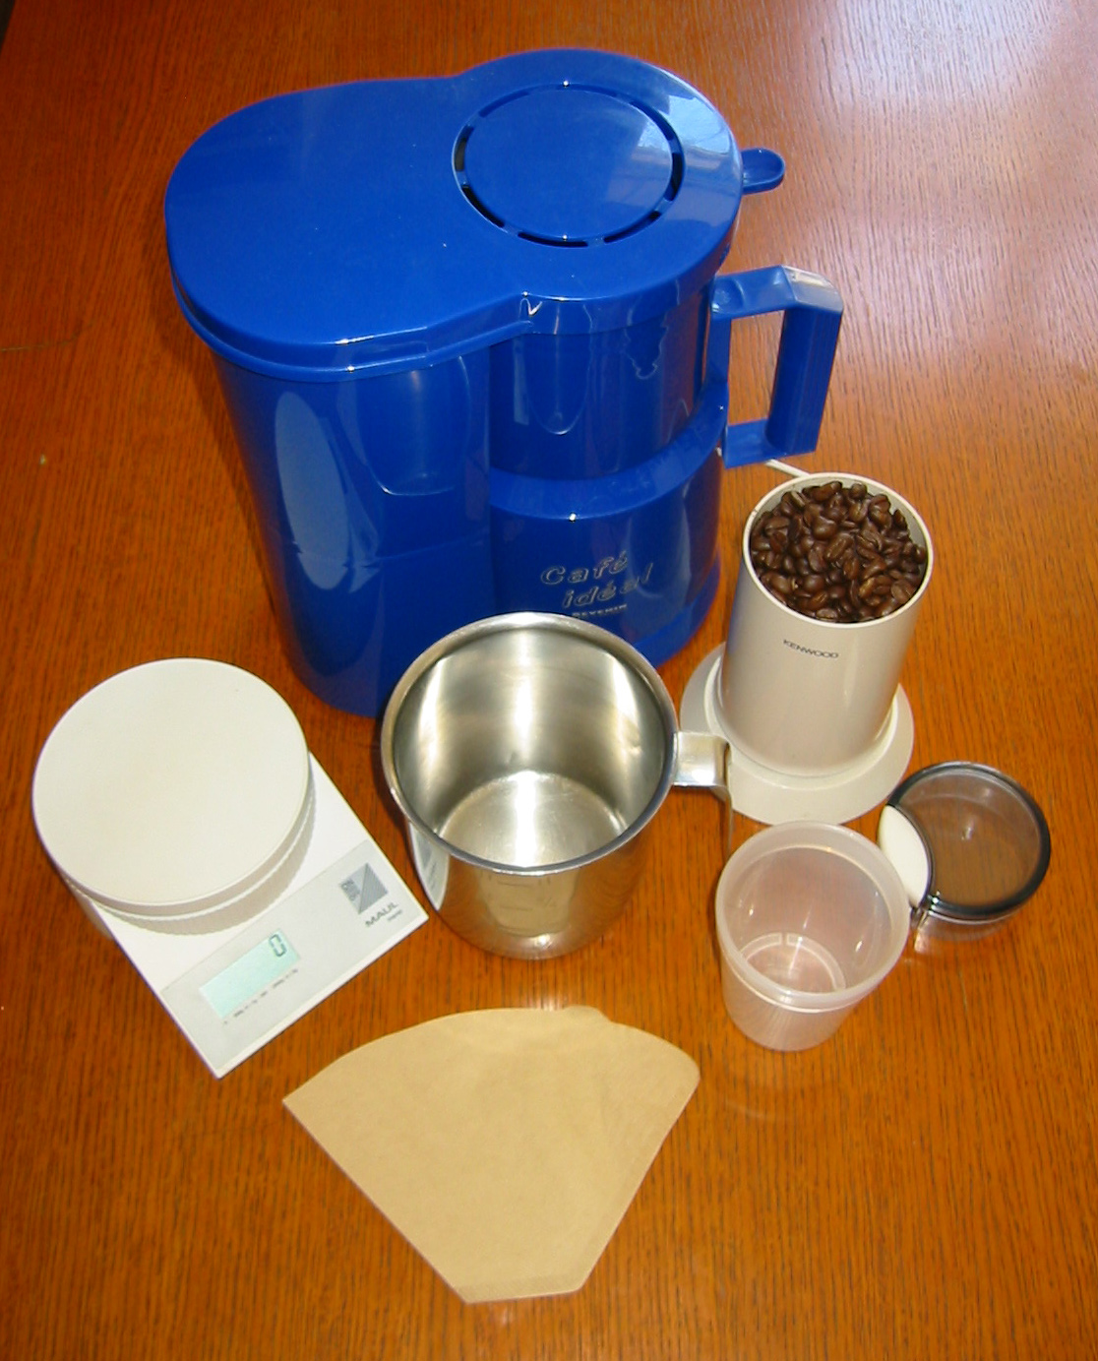
Coffee machine
Scales
Coffee grinder, beans
Figure 9: Materials for making coffee
Each group needs a coffee machine. The coffee grinder can be shared between the groups. At least two scales should be used, it would be best, however, to have one per group. Alternatively this exercise can be carried out with tea.

Case study: Making coffee - A
Task:
The management has requested you to analyse the production of a pot of filter coffee. Draw up a balance of the process, evaluate it and present your findings to the general manager.
Raw materials: Coffee beans, water
Process materials: Coffee grinder, coffee machine, filter, scales,
container, transparencies/flipcharts and pencils
First draw up a test plan and determine the testing process for collecting all relevant data.

Basic conditions:
- The energy consumption is not taken into account;
- Portion of left over coffee after grinding: minimum 1 g;
- The coffee powder has to be disposed of as waste.

A chemical analysis has led to the following results: about 7.5% of coffee were extracted.
Reference value (for check): humidity contained in wet coffee grounds: 55 – 75%.

Evaluation
- Draw a flowchart.
- Draw up an overall balance and individual balances for water and coffee.
- Provide at least two proposals for improvement (on the material level).
- Present the results to the “management”.

Evaluation of the material flow analysis of making coffee

 | Group A | B | C
INPUT
- Coffee beans
- Water
- Filter
Σ in
OUTPUT
- Coffee
* Water
* Extract
- Coffee grounds
* Coffee rest
* Water
(%-H₂O)
* Filter
- Waste from grinding
- Loss by evaporation
- Others
* H₂O in coffee machine
* Water losses on table ...
Σ out

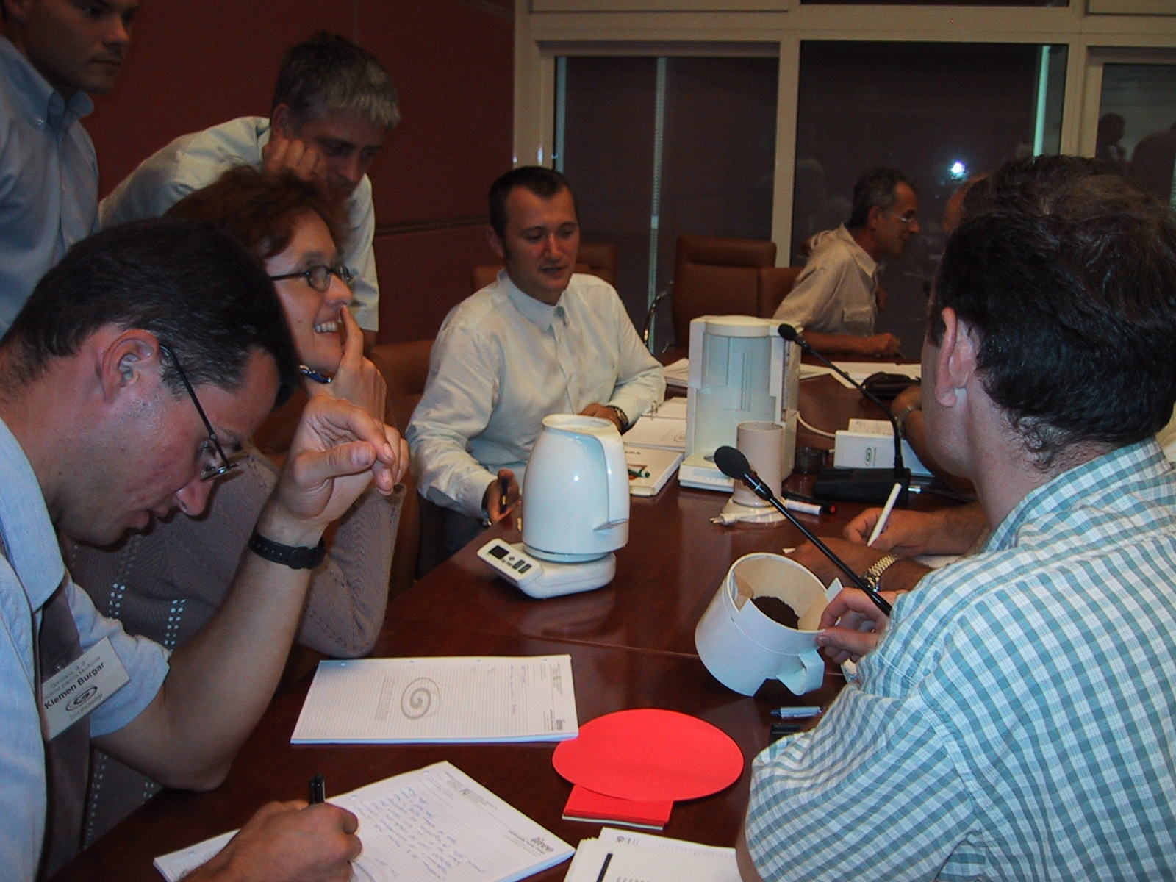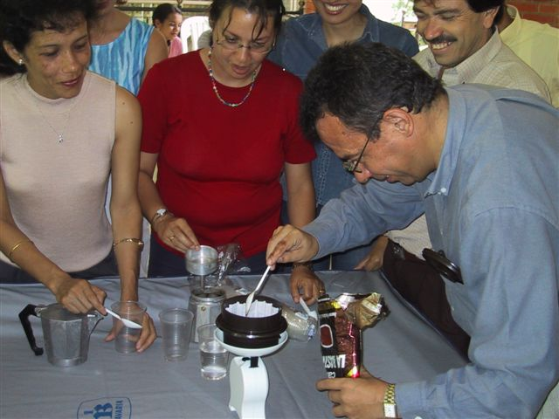
Figures 10 and 11: The participants make coffee

Case study: Making coffee – B
Task:
The management has requested you to analyse the production of a pot of filter coffee. Draw up a balance of the process, evaluate it and present your findings to the general manager.
Raw materials: Coffee beans, water
Process materials: Coffee grinder, coffee machine, filter

First, draw up a test plan and determine the testing process for collecting all relevant data.

Weighing tests have provided the following data:
Coffee beans 40 g
Water introduced into the coffee machine 950 g
Dry filter 2 g
Residues from grinding 1 g
Coffee made 876 g
Residual water in coffee machine 2 g
Coffee grounds (filter, coffee, water) 105 g
Evaporated water ....... g

A chemical analysis has led to the following results: about 7.5% of coffee were extracted.
Reference value (for check): humidity contained in wet ground coffee: 55 – 75%.

Evaluation:
- Draw a flowchart.
- Draw up an overall balance and individual balances for water and coffee.
- Provide at least two proposals for improvement (on the material level).
- Present the results to the “management”.

Evaluation of the material flow analysis

of making coffee – B
INPUT  - Coffee beans  - Water  - Filter  Σ in | 40  950  2  992 g
OUTPUT  - Coffee  * Water  * Extract  - Coffee grounds  * Coffee rest  * Water  (%-H₂O)  * Filter  - Waste from grinding  - Loss by evaporation  - Others  * H₂O in coffee machine  * Water losses on table ...  Σ out | 876  873  3  105  36  67  65%  2  1  8  2  992 g

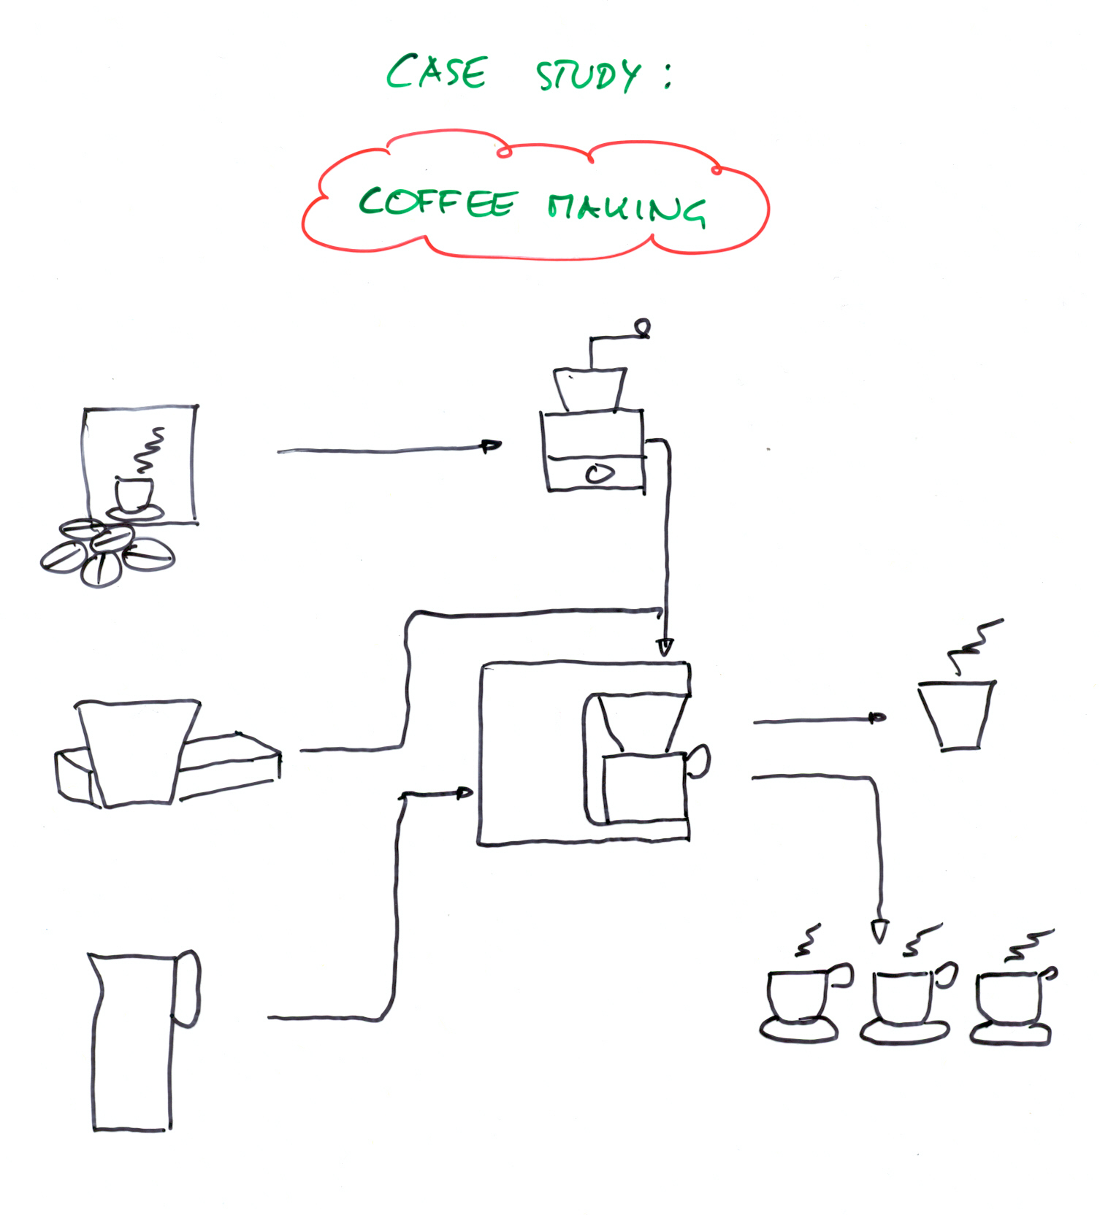
Figure 12: Flowchart: making coffee
Measures/strategies for minimization (without energy)

Good housekeeping:
- Improved material utilization;
- Grinding of larger quantities;
- Define recipes;
- Define indicators;
- Train operators;
- Provide quality control.

Technological modifications:
- Use a new coffee machine to reduce losses due to evaporation and waste heat;
- Grinder producing less residues (complete emptying);
- Finer grinding;
- Use bigger filters;
- Use espresso machine as completely different technology.

Substitution of raw and process materials:
- No paper filter (goldfilter);
- Possibility of using pre-ground coffee;
- Instant coffee.

Internal/external recycling:
- Composting of ground coffee and filters;
- Reuse coffee grounds for a low-quality cup of coffee;
- Reuse coffee grounds as pesticide (e.g. against potato beetle).

Other/organizational measures:
- Time-travel diagram to optimize coffee quantities.

Product modification:
- Turkish coffee;
- Stronger, weaker coffee;
- Coffee sweets, coffee pills;
- Instant coffee;
- …

3-3 Water balance for an office and residential building

A water balance for an office and residential building has to be drawn up to assess water saving options for the use of cold and hot water, but also to provide a more accurate account of the costs for water consumption to the users.

The building consists of the main building with:
8 residents (students) on the top floor;
18 residents (workers) on the first and second floor;
Office 1 on the ground floor with 28 employees;
Office 2 on the ground floor with 17 employees;
A garden with a water hose for watering and filling a little lake.

The entire building has only one water meter. Last year’s overall water consumption amounted to 1 650 m³ of water.

For a first water balance, typical values of daily consumption from reference documents are entered. It was discussed or estimated in detail with the management of the building how many days per year people spend in the building.

Total water Thereof: Days spent in
consumption hot water the building
per person per person
Resident 150 l/day 35 l/day 280 days/year
Employee 40 l/day 10 l/day 220 days/year
Ground watering 1 l/m² 100 days/year

In the garden 250 m² are watered, 35 m³ are used for filling the little lake once a year.

Please draw up a water balance for the respective areas.
What is the daily consumption of hot water?

Solution:
Total water Thereof: Days spent in
consumption hot water the building
per person per person
Resident 150 l/day 35 l/day 280 days/year
Total/hot water 1 092 m³ per year 254.8 m³ per year

Employee 40 l/day 10 l/day 220 days/year
Total/hot water 396 m³ per year 99 m³ per year

Watering 1 l/m² 100 days/year
Total water 25 m³ per year

In the garden 250 m² are watered, 35 m³ are used for filling the little lake once a year.

The total annual water consumption calculated amounts to 1 548 m³ and 353.8 m³ of hot water are required. Compared to the annual volume of 1 650 m³ measured by the water meter 102 m³ are missing.
3a) Please set up a water balance for the respective areas. What is the daily consumption of hot water?
26 persons x 35 l + 45 persons x 10 l = 1 360 l per year
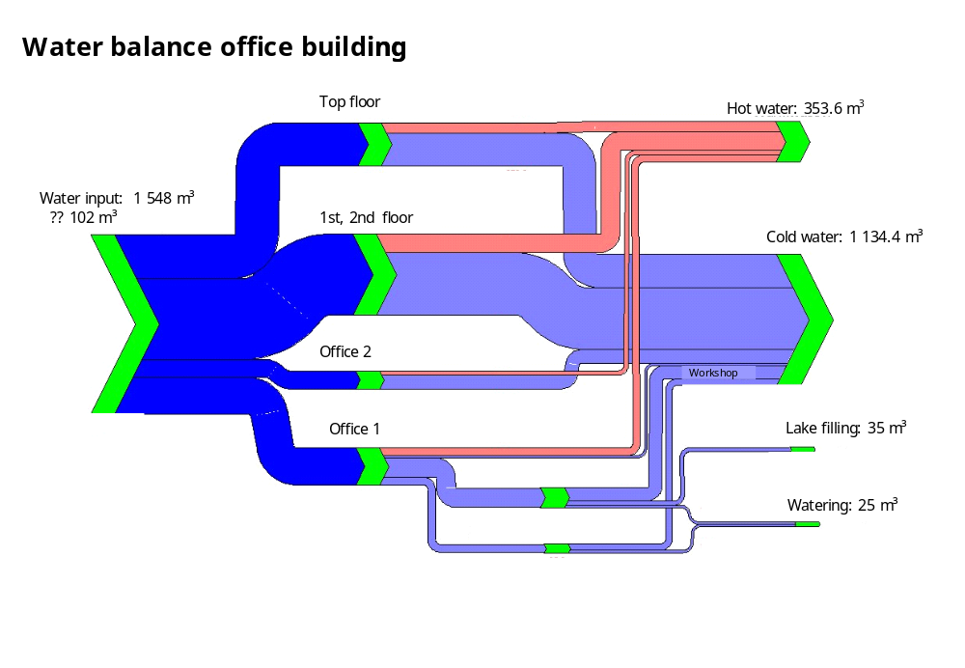

Figure 13: Sankey diagram: Water balance of an office and residential building

3-4 Pickling process
In this exercise, a material balance has to be drawn up. The process, flowchart and process data are set. This exercise is rather difficult because it includes a chemical reaction. It should only be used for experienced workshop participants.

Exercise:
Prior to the further treatment of the surface, workpieces made of iron need to be pickled in an aqueous solution of chloric acid. Rust at the surface (Fe₂O₃) reacts with chloric acid (HCl) and forms iron chloride (FeCl₃). Assumption for this exercise: the chemical reaction is complete.
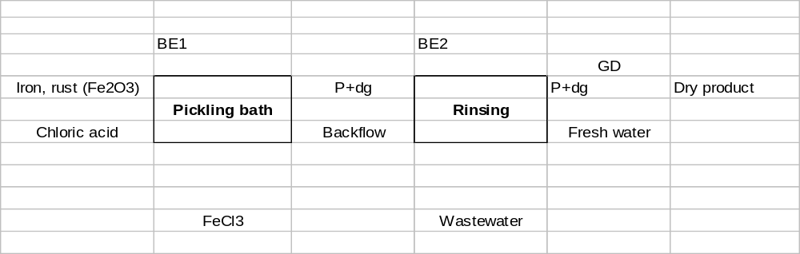After the pickling process bath, the workpieces are rinsed with water. During the two rinsing baths, some water and acid evaporate. When the workpieces are taken out of the rinsing baths, water and acid remains on the surface (the so-called drag-out). Finally the workpiece is dried by the ambient air.
Task:
Please formulate the reaction equation.
Calculate the mass flows.
Analyse the balance for the chloric acid.
Find and discuss CP options.

For further information, see next page.
Further information:

The following data are known:
The metal input amounts to 10 000 kg/h, of which around 100 kg/h is rust (Fe₂O₃).
The evaporation during the baths amounts to 30 kg/h in the pickling bath (BE1) and to 10 kg/h in the rinsing bath (BE2). The vapour has the same composition and concentration as the baths.
When the workpieces are taken out of the baths, bath solution, the so-called drag-out (dg), remains on the surface. This drag-out amounts to 20 kg/h for each bath (same composition/concentration as the baths).
The fresh solution contains 80% of chloric acid (HCl) and 20% of water. Approximately 190 kg/h are used.
Rust reacts with HCl to form FeCl₃.
FeCl₃ is removed from the pickling bath. During this process, some more pickling solution remains with the FeCl₃ (66.6% FeCl₃; 33.3% solution).
The acid concentration in the pickling bath is 100 g/l (density 1 kg/l).
The acid concentration in the rinsing bath is approximately 10 g/l.
The rinsing water is partly put back into the pickling bath, the rest of the wastewater is treated.
Atomic mass: Fe 56 Cl 35.5 H 1 O 16

Solution:
Fe₂O₃ + 6 HCl => 2 FeCl₃ + 3 H₂O
160 + 219 325 + 54 in mass units
100 kg of rust reacts with 136.875 kg of HCl (100 x 219/160) to form ~203 kg of FeCl₃ (100 x 325/160) and 33.75 kg of water.
The FeCl₃ removed contains 33.3% solution, in total 203 kg/0.667 = 304.5 kg/h.

Pickling bath:
IN: OUT:
10 000 kg/h iron and rust 9 900 kg/h iron and 20 kg/h drag-out
~ 190 kg/h acid 30 kg/h BE1
64.5 kg/h backflow 304.5 kg FeCl₃ (wet)

Rinsing bath:
20 kg/h of drag-out with 100 g/l of acid (2 kg/h of acid) enter the bath. To dilute this drag-out concentration to 10 g/l of acid, additional 180 kg/h of fresh water are used.
IN: OUT:
9 900 kg/h iron and 9 900 kg/h iron and
20 kg /h drag-out pickling 20 kg/h drag-out
180 kg/h rinsing water 10 kg/h BE2
64.5 kg/h backflow
105.5 kg/h wastewater

Acid balance:
IN pickling: OUT pickling:
~ 190 kg/h x 80% = 152 kg/h Reaction: 136.9 kg/h
BE1: 3 kg/h
FeCl₃ wet 10.15 kg/h
Backflow 0.65 kg/h Drag-out pick. 2 kg/h

IN rinsing: OUT rinsing:
Drag-out pickling 2 kg/h BE2: 0.1 kg/h
Drag-out rins. 0.2 kg/h
Backflow 0.65 kg/ h
Wastewater 1.05 kg/h

Typical CP options:

- Improve pickling (using less acid, incomplete reaction);
- Install cascade rinsing to use all rinsing water as make-up water;
- Separate acid from FeCl₃;
- Cover the pickling bath to reduce evaporation;
- Remove rust partly by hand;
- Recover the losses form evaporation by conveying the air through a spray wash to collect the acid;
- …

